

Results of the K-city Network: Global Cooperation Program 2021

□ The Ministry of Land, Infrastructure and Transport of the Republic of Korea (MOLIT) unveiled the project selection result for the K-City Network: Global Cooperation Program 2021(K-City Network 2021).

ㅇ Among the 111 projects in 39 countries submitted for application, 11 projects were selected for implementation in 11 countries this year.

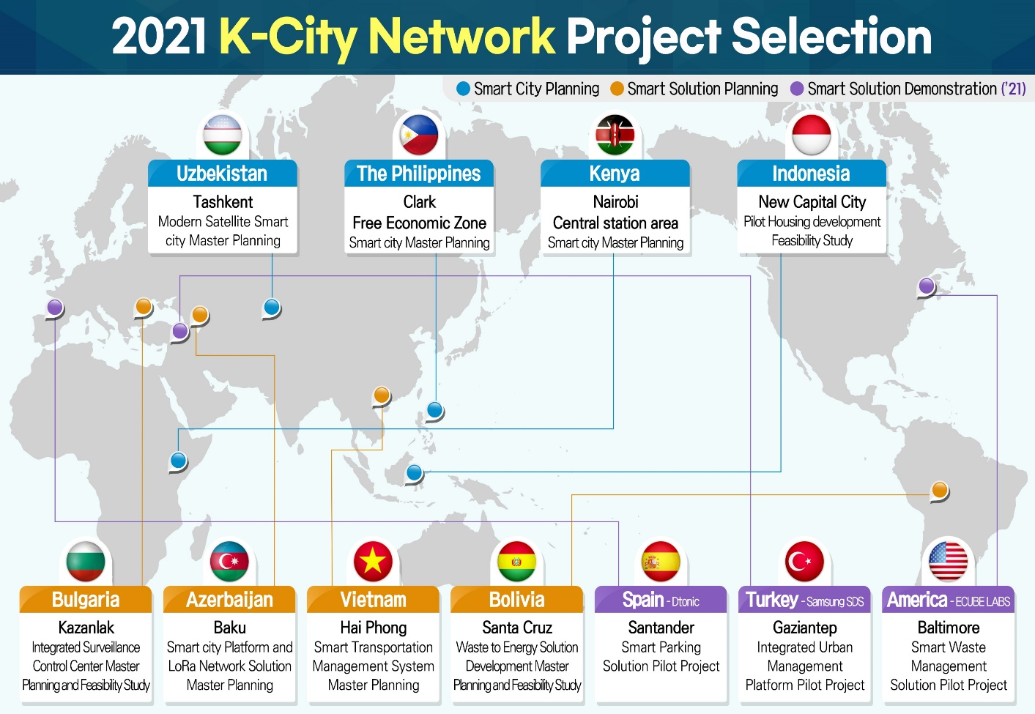

□ The K-City Network: Global Cooperation Program is a government-to-government cooperation program MOLIT launched in 2020 to share Korea’s smart city development expertise and experience. The program provides funding and technical support for basic study development for a smart city project like a master plan or feasibility study and a short-term training course in Korea for the host government officials. The program offers three sub-programs for recipient countries to choose from based on their needs. Below are the summary of the K-City Network 2021 and the list of 11 projects selected.

K-City Network 2021
Program | Purpose | Funding (KRW)
Smart City Planning | Planning for a large-scale or green field smart city development project | 400million to 600million
Smart Solution Planning | Designing of a smart solution to address a specific urban problem | 200million to 300million
Smart Solution Demonstration | Introduction of Korea’s solutions for pilot operation in a foreign country | 400million to 600million

Smart City Planning
□ After reviewing 57 projects in 24 countries, the following four projects in four countries were selected.

- (The Philippines) Master Plan Establishment for the Clark Smart City Complex: Urban Development Project

ㅇ Proposed by the Clark Development Corporation of the Philippines, the project will develop a master plan for a smart city complex to be created on a former air force housing compound site in the Clark Freeport Zone. The project will be the first case of bilateral collaboration on smart city development.

- (Indonesia) Feasibility Study and Pilot Project for Housing Development in the New Capital City

ㅇ The project will build upon the basic concept plan of the New Capital City in Indonesia developed under the K-City Network Program 2020. The project will conduct feasibility study for the housing complex construction project planned for the Indonesian public officials to be relocated to the new city.

- (Uzbekistan) Creation of an International Innovative Construction Complex and a Modern Satellite City in Yangikhayot and Bektemir Districts of Tashkent City

ㅇ The city of Tashkent was recently expanded after merging with two nearby districts. To cope with rising population and expand urban infrastructure, the project will deliver a basic plan for developing an innovation complex and a smart satellite city in the merged city.

- (Kenya) Nairobi Railway City Pilot Area Planning for Smart City Development Plan

ㅇ Overseen by the Ministry of Transport, Infrastructure, Housing and Urban Development, the project will draft a comprehensive development plan for the Nairobi Central Station and a pilot city area around the station where a smart city will be located. A Korean company also developed the master plan that precedes this development plan with funding from the World Bank.
.
Smart Solution Planning
□ For Smart Solution Planning, 40 applications were received from 16 countries. Following the solution development proposals elaborated below, basic studies to improve transportation, environment, internet connection, and urban management in four cities will be established.
- (Vietnam) Transportation Management System Development for Hai Phong City

ㅇ The project will produce a master plan for building a smart traffic monitoring system in the Hai Phong City to alleviate traffic congestion in the densely populated city.

- (Bolivia) Smart Waste Collection and Waste to Energy Solution Development for Santa Cruz de la Sierra

ㅇ Applied by the city of Santa Cruz de la Sierra, the project will propose a comprehensive solution on waste collection and conversion into energy source

- (Azerbaijan) Smart City Platform and LoRa Network Development Project in Baku

ㅇ Azerbaijan has been pursuing smart city infrastructure development as a national priority. The project will lay out a plan for building a smart city platform to link smart city services introduced in the last few years as well as a LoRa network for the capital city.

- (Bulgaria) Integrated Surveillance Control Center Development in Kazanlak

ㅇ The project will deliver a master plan and feasibility study for upgrading the surveillance center in Kazanlak by introducing a smart surveillance system. With the smart monitoring solution in place, the role of the center will expand from simple monitoring to proactive monitoring and response based on inputs from the CCTV network

Smart Solution Demonstration
□ Smart Solution Demonstration is a sub-program of the K-City Network launched this year to give a Korean solution developer or provider a chance to run pilot operation, often a requirement for bidding for overseas infrastructure projects and cross-validate the solution in a foreign country. Given the objective of the program, Korean companies partnering with overseas host governments or agencies apply for the program.

□ Based on presentations made by Korean companies in joint virtual conferences with the overseas partnering agencies, the project selection committee approved piloting of three solutions- an urban management platform, waste management solution, and smart parking system- out of 14 applications proposed by 12 countries.

- (Turkey) Piloting of an Integrated Urban Management Platform in Gaziantep

ㅇ The project will execute the master plan developed last year in the K-City Network 2020. Reflecting upon the master plan on smart data coordination center establishment in Gaziantep, Samsung SDS, the developer of the master plan, will form a consortium with small and medium-sized enterprise to import its urban management platform to Gaziantep and run a pilot operation of the platform in partnership with the city authority. Through the pilot operation, various urban management functions like traffic management and enforcement (ei, truck overloading) as well as crime prevention will be integrated.

- (America) Piloting of a Waste Management Solution in Baltimore

ㅇ Proposed by Korea’s Ecube Labs and the city government of Baltimore, the project will introduce the Ecube’s smart waste management solutions, including a data collection platform for waste recycling and reuse and a matching platform for waste collection.
- (Spain) Piloting of a Smart Parking Solution in Santander

ㅇ In Santander, a Spanish city well-known in Europe for its early adoption of smart solutions, Dtonic Corporation will work with the University of Cantabria of Spain to provide smart parking services run by the Smart City Data Hub, an urban data platform developed with funding from MOLIT.

□ In June, MOLIT will secure appropriations for individual projects with selection of the Korean companies that will execute the projects due by July. Upholding the spirit of the program to promote the government-to-government collaboration, the host governments or partnering agencies will be consulted throughout the program, including the company selection. The eight projects under Smart City Planning and Smart Solution Planning will start from August and the three projects of Smart Solution Validation will begin from July.

□ CHOI Im-rak, Director General for Urban Policy of MOLIT said, “MOLIT appreciates the overwhelming response we received for this year’s K-City Network Program and will offer our upmost support to facilitate collaboration on the projects.”

